Keerthi sweets

1 INTRODUCTION

* 1. Overview A brief description about your project
  2. Purpose The use of this project. What can be achieved using this

2.Problem Definition & Design Thinking

2.1 Empathy Map Paste the empathy map screenshot

2.2 Ideation & Brainstorming Map Paste the Ideation & brainstorming map screenshot

3 RESULT

Final findings (Output) of the project along with screenshots.

4 ADVANTAGES & DISADVANTAGES

List of advantages and disadvantages of the proposed solution

5 APPLICATIONS

The areas where this solution can be applied

6 CONCLUSION

Conclusion summarizing the entire work and findings.

7 FUTURE SCOPE

Enhancements that can be made in the future.

8 APPENDIX

1. Source Code Attach the code for the solution built.

1.introduction

1.1 Overview A brief description about your project

A project overview includes basic information, such as the project name, project manager, and sponsors. It also includes detailed information that summarizes the project's value, the problem it may solve, and the goals the team hopes to achieve

Sweets are small sweet things such as toffees, chocolates, and mints. A sweet is something sweet, such as fruit or a pudding, that you eat at the end of a meal, especially in a restaurant. The sweet was a mousse flavoured with coffee. A sweet smell is a pleasant one, for example the smell of a flower.

1.2 Purpose The use of this project. What can be achieved using this

Starting a sweet shop can be a rewarding and lucrative business venture for those who are passionate about baking and confectionery. Some potential benefits of starting a sweet shop include:

1. High demand: There is always a demand for sweet treats, especially in busy urban areas.
2. Flexibility: A sweet shop can be run as a full-time business or as a part-time venture, depending on the owner's goals and resources.
3. Personal satisfaction: For those who love to bake and create new recipes, a sweet shop can be a fulfilling way to turn a hobby into a career.
4. Potential for growth: A successful sweet shop can potentially expand to multiple locations or even franchise the business.
5. Opportunity to be creative: A sweet shop owner has the opportunity to be creative and try out new recipes and flavor combinations.

It's important to keep in mind that starting a sweet shop, or any business, requires careful planning, dedication, and hard work. It's also important to consider the potential challenges and costs involved in starting and running a business.

* + - Gummy sweets.
    - Sour sweets.
    - Fudge, caramel, toffee and nougat.
    - Popular sweet brands.
    - Lollipops.
    - Candyfloss.
    - Chocolate covered nuts.
    - Chewing gum and bubble gum.
    - Mints.
    - Sweets from other countries, including the USA, India and Belgium.

Some sweet shops also choose to stock other products, such as crisps and other savoury snacks, ice cream, milkshakes, vegan products, cakes and other baked products.

When setting up a sweet shop business, it is recommended that you conduct some market research. This can help you decide what type of sweet shop you want to run and help you to make your sweet shop business a success.

2.Problem Definition & Design Thinking

2.1 Empathy Map Paste the empathy map screenshot

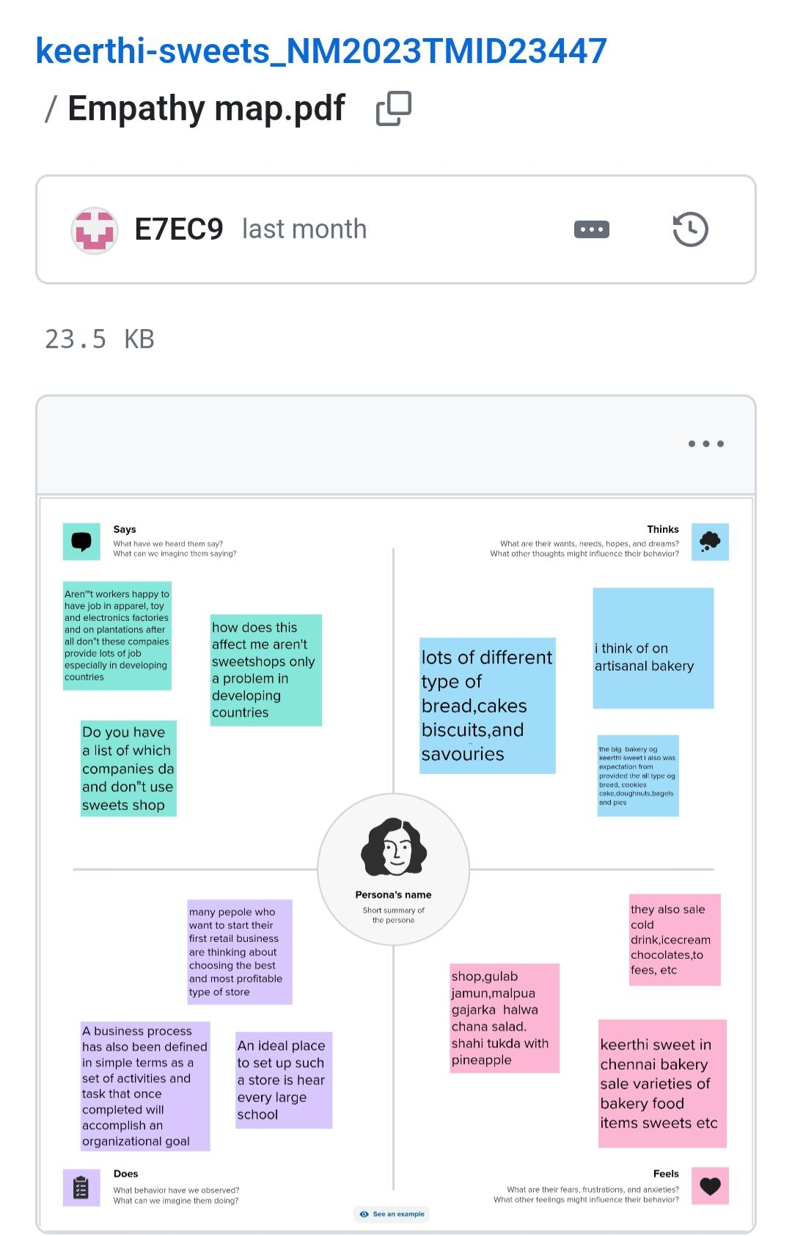

2.2 Ideation & Brainstorming Map Paste the Ideation & brainstorming map screenshot

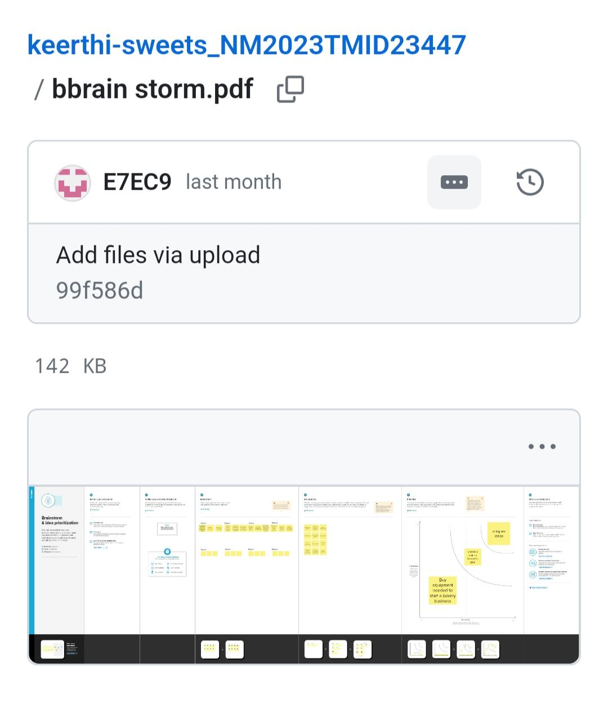

3.RESULT

3.1 GST REPORT

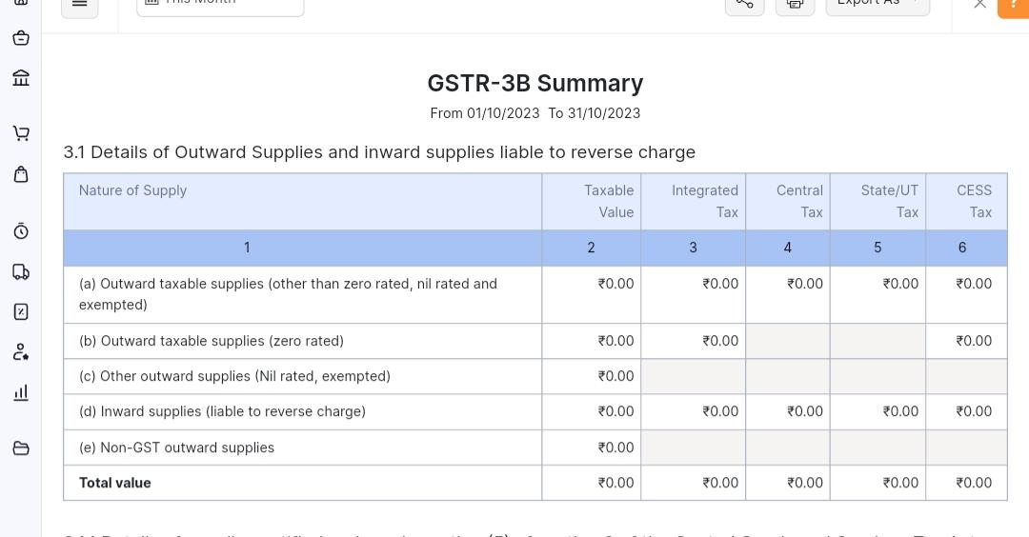

3.2 INVOICE DETAILS

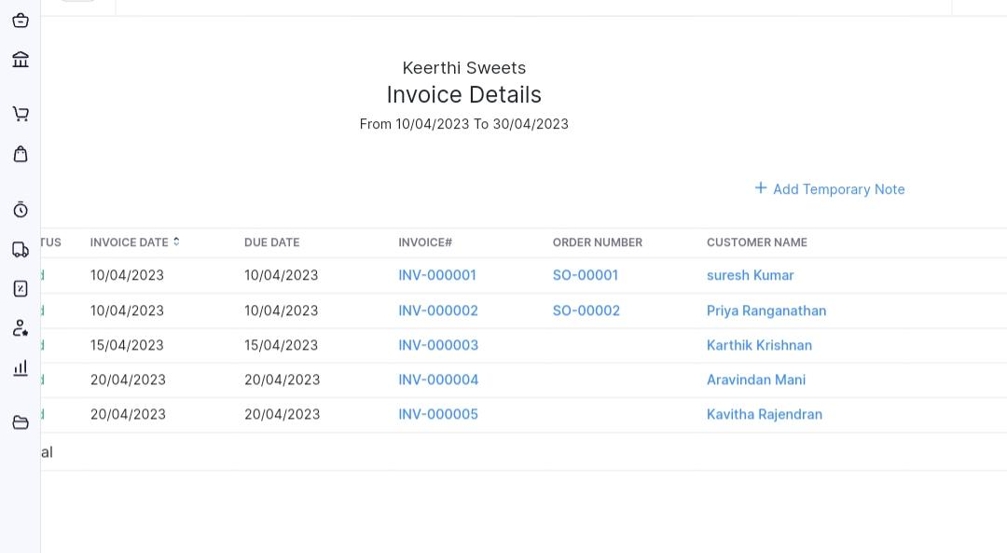

3.3 Againg Receivable summary( Invoice Details)



3.4 Item

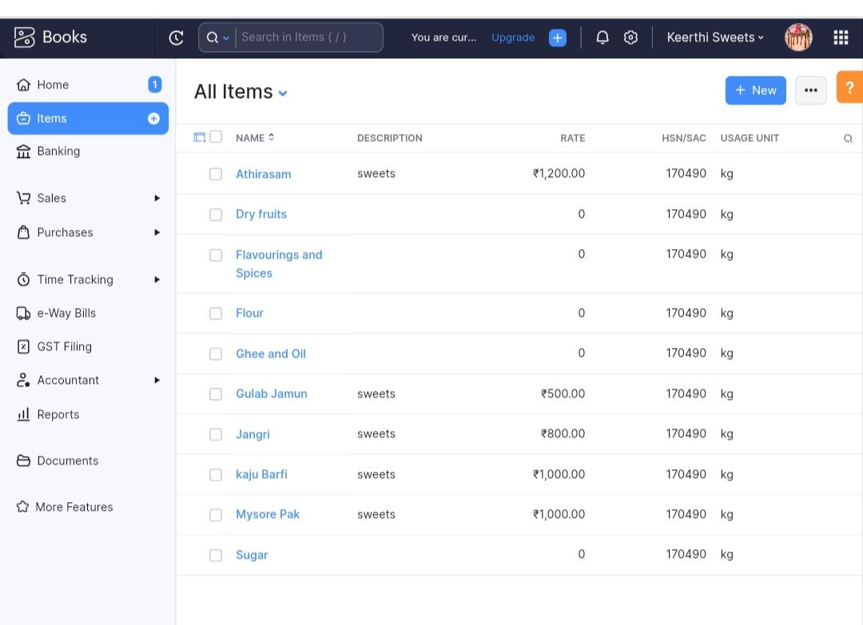

3.5 Sale Invoice

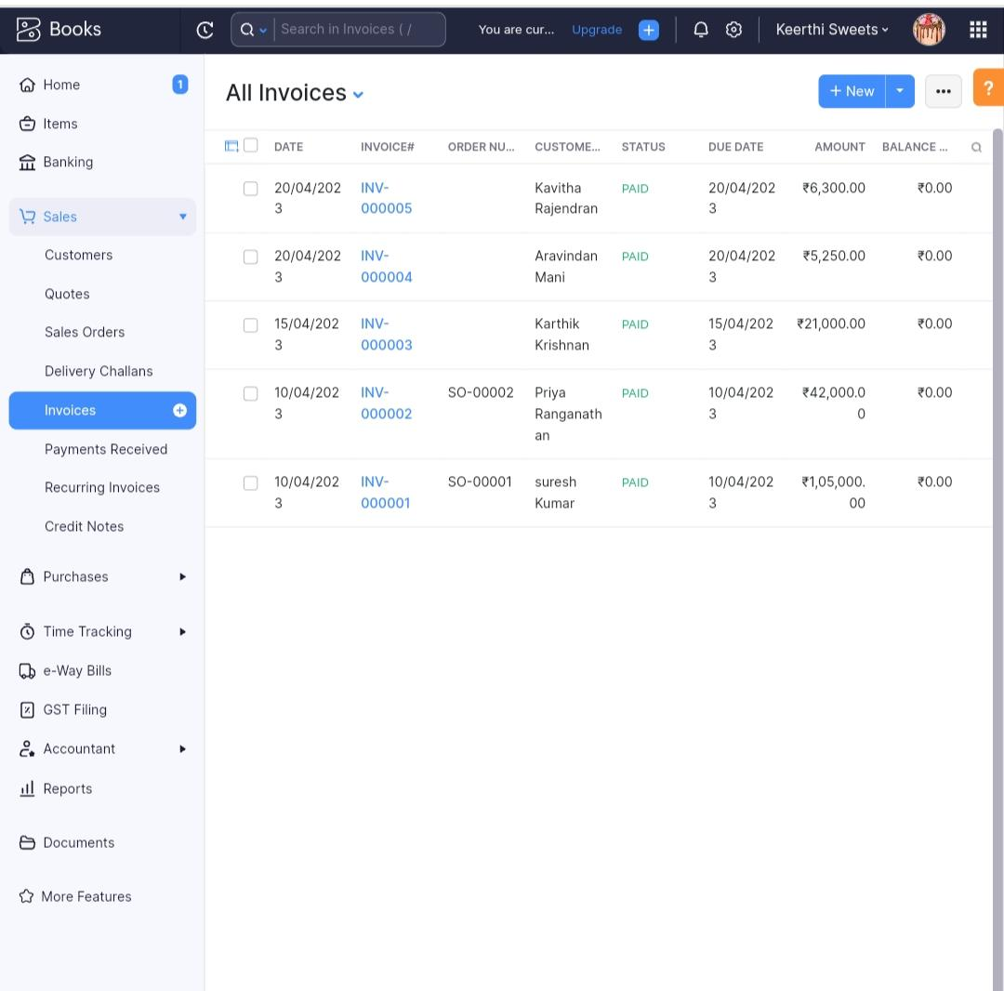

3.6.purchase order(bill)

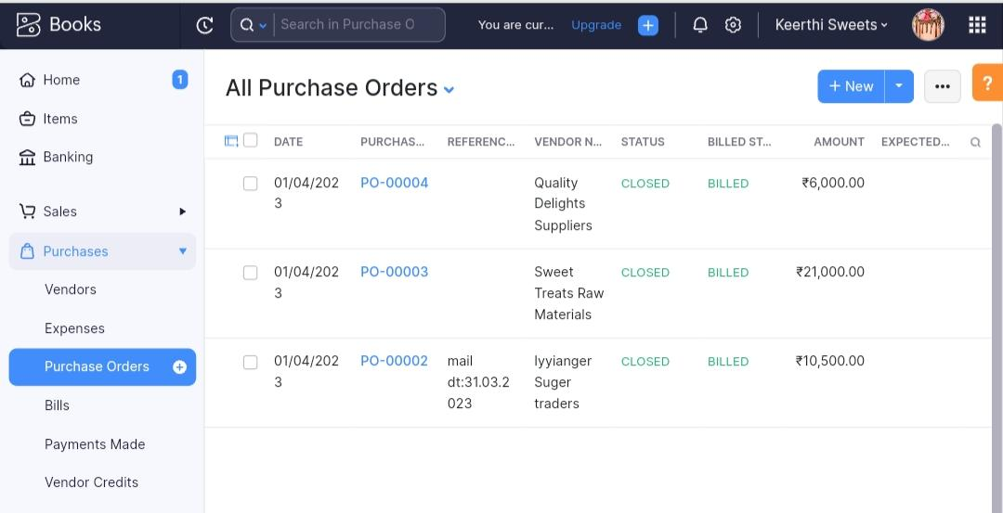

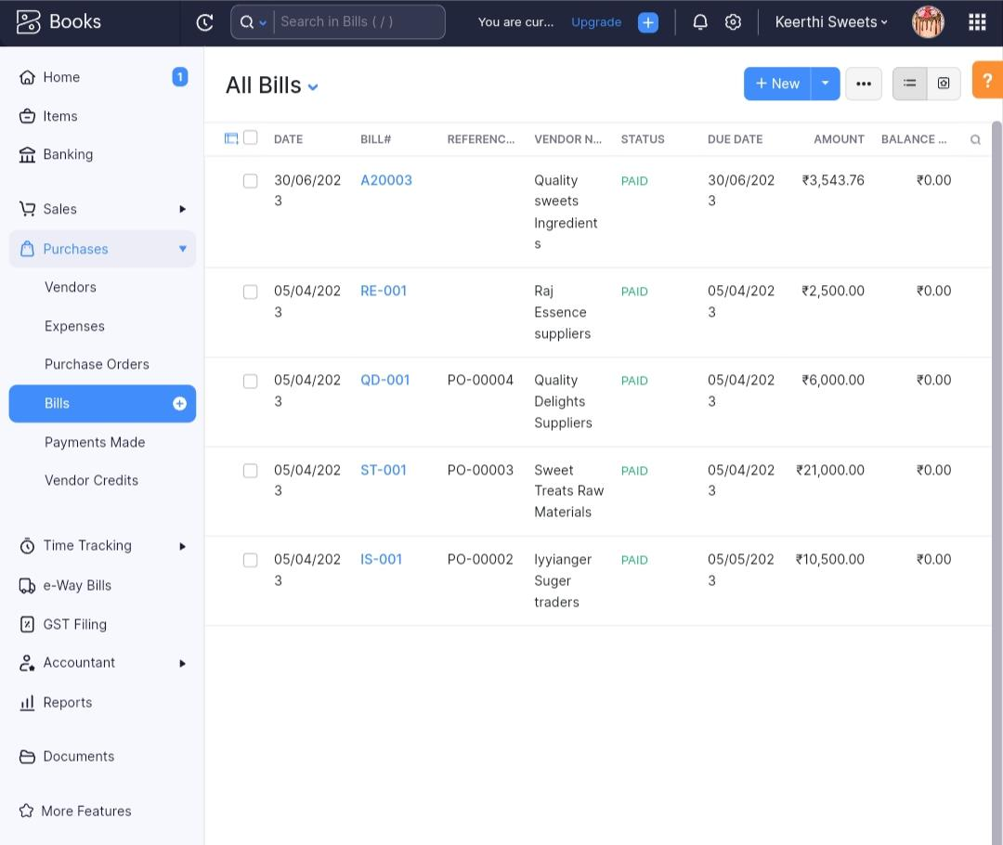

3.7.customers.

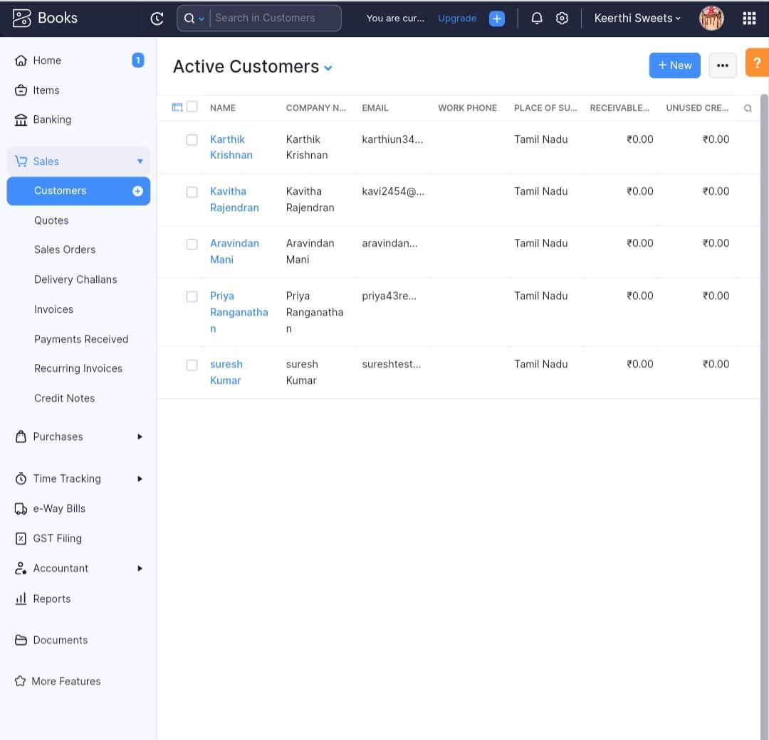

3.8 vendor.

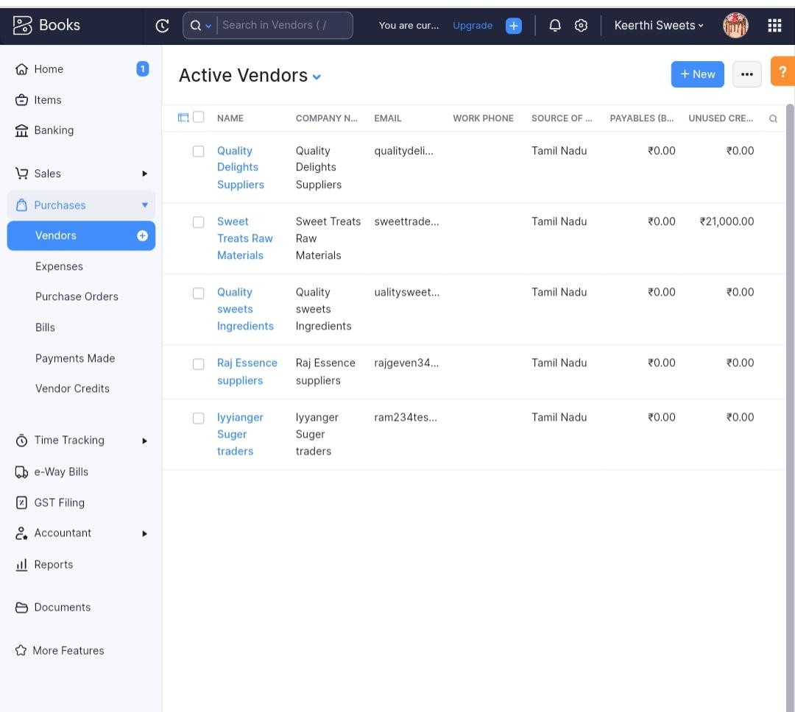

3.9 Banking

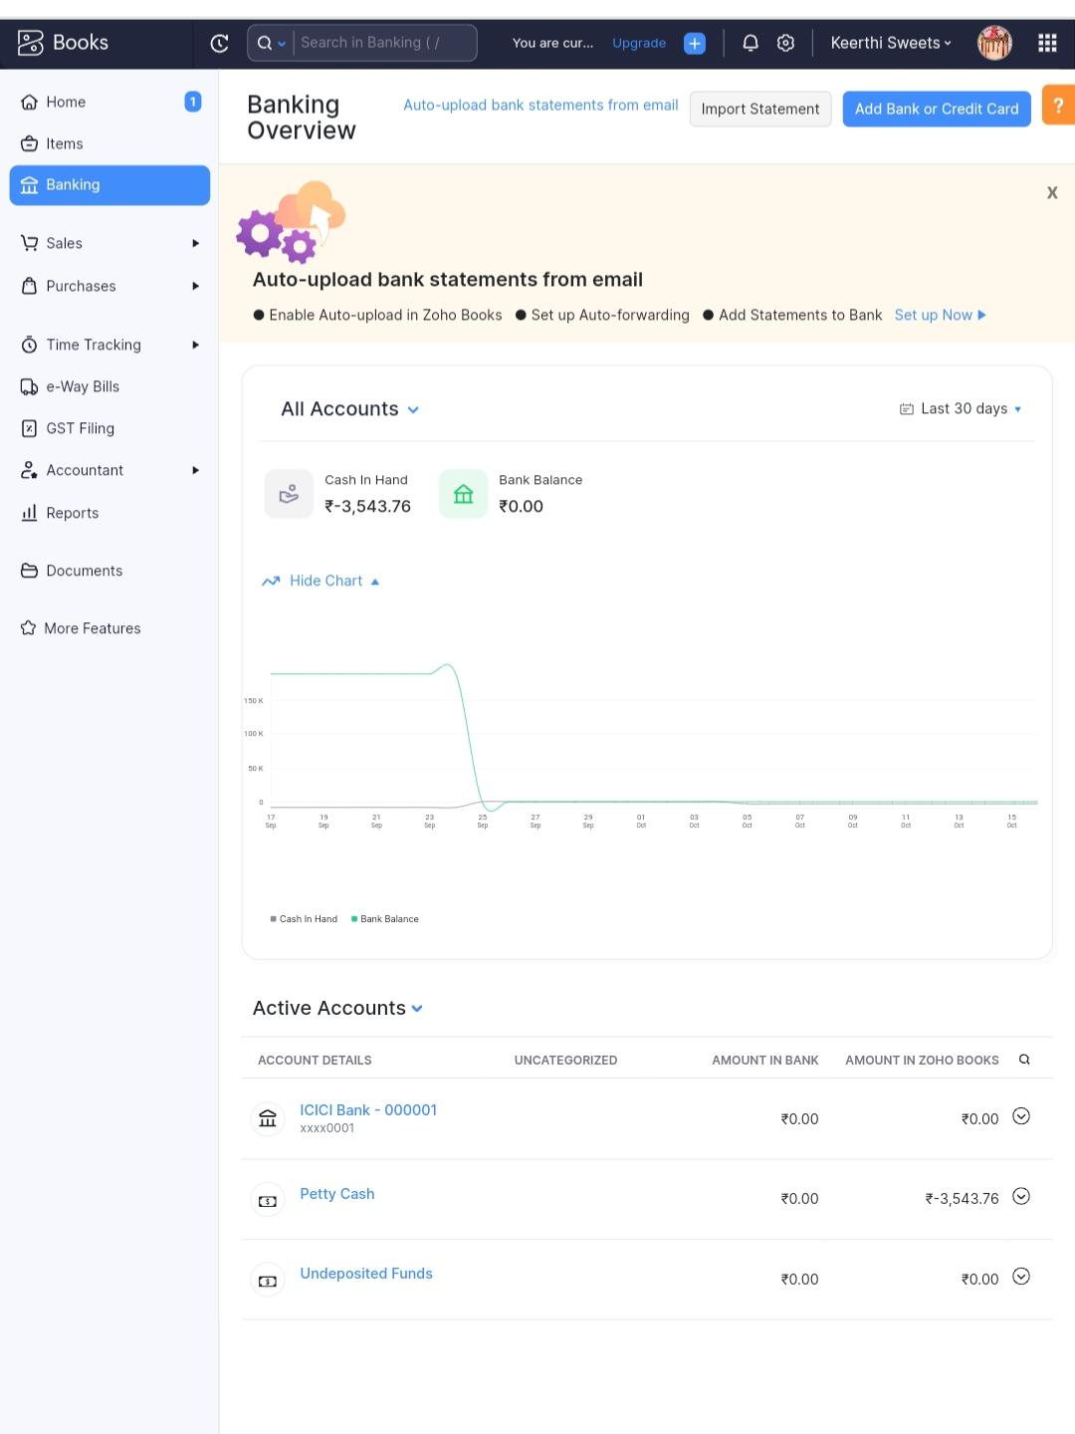4.ADVANTAGES AND DIS ADVANTAGES

Eating sweets in moderation can be a part of a balanced diet and can provide enjoyment. However, consuming excessive amounts of sweets can have both advantages and disadvantages. Here are some of the advantages and disadvantages of eating more sweets:

Advantages:

1. Instant energy boost: Sweets, particularly those high in sugar, can provide a quick source of energy due to their high glycemic index. This can be beneficial during times of low energy or intense physical activity.
2. Mood enhancement: Sweets are often associated with pleasure and can temporarily improve mood by triggering the release of endorphins, the "feel-good" hormones.
3. Social enjoyment: Sweets are commonly enjoyed during celebrations and social gatherings, contributing to the enjoyment and bonding experiences with others.

Disadvantages:

1. Increased risk of weight gain: Many sweets are high in calories and low in nutritional value. Overconsumption can lead to weight gain and an increased risk of obesity, which is associated with various health problems.
2. Dental health issues: Frequent consumption of sugary foods and drinks can contribute to tooth decay and cavities. The bacteria in the mouth feed on sugar, producing acids that erode tooth enamel.
3. Nutritional deficiencies: Sweets are often low in essential nutrients such as vitamins, minerals, and fiber. If sweets replace more nutritious foods in the diet, it can lead to imbalances and deficiencies.
4. Blood sugar spikes and crashes: Consuming excessive sweets can cause rapid spikes in blood sugar levels, followed by subsequent crashes. This can lead to fluctuations in energy levels, mood swings, and increased hunger.
5. Increased risk of chronic diseases: A high intake of sweets, particularly those high in added sugars, is associated with an increased risk of developing conditions like type 2 diabetes, heart disease, and metabolic syndrome.

It's important to strike a balance and consume sweets in moderation as part of a varied and nutrient-dense diet to minimize the potential negative effects on health.

5.Application

Can Stock Photo has now ceased operations.

After nearly 20 years in business we have been forced to make this very difficult decision and would like to thank our many thousands of talented contributors and customers for making it possible. The industry has changed significantly over this time, with CanStock launched in 2004 during the early mass adoption of digital cameras, and before "social media" was even a phrase. Today of course everyone has a capable digital camera in their pocket, and the advent of AI means amazing images can be created from programs with just a few keywords. Decreased business and increasing costs has made it no longer possible to keep operating, to our great disappointment.

As advised in our [announcement](https://nyc3.digitaloceanspaces.com/static.us-east/static/web/files/announcement.pdf) on September 1st, all our membership agreements have now been terminated. For eligible contributors who filed a final payment request prior to the September 30th deadline, you should receive it by December 31st.

Thank you for everything,

- The Can Stock Photo Team

6. Conclusion

 business’ number one priority is bringing in customers. How they bring in those customers depends on the audience they are trying to reach. In The Sweet Shop’s case, they are trying to attract young adults, specifically FSU students. You would think that since The Sweet Shop is so close to campus, their social media sites would be very popular. Surprisingly, they are not. This is because of a number of things ranging from chance to mistakes that the owners themselves made. The Sweet Shop’s colorless website seems to be directed towards older adults instead of college students. Their Facebook’s posts are not entertaining, nut the rest of their page is successful. Facebook is a good example for how social media is not always going to be the best way to capture your audience. Their two twitter accounts are good examples of how canoes can e made to accommodate for an audience's interests. If The Sweet Shop can make changes to their other media like they did for Twitter, they will see their number of customers grow in no time. However, for media to attract these customers, all their media sites should be connected in some way, like links to other sites, so the business can access their audience at all times from different kinds of media. I argue that if The Sweet Shop were to improve their current media to attract a younger audience and combine their media together, they would bring in more students than they do now.

## **So what?**

So, what now? What can you learn from all this? I hope you learned how NOT to use social media and media systems! But I also hope that, through The Sweet Shop’s mistakes, you now know how to use media and media systems correctly. Using color, images, and font, you can attract any audience you want, not just young adults! Just make sure you keep your audience in mind! What looks good to you may not appeal to your audience! You also know now how important it is to connect these media together to make a system so your audience is constantly informed. The next time you are thinking about how to plan out a project or a website like this one, think about this website and what you learned from it!

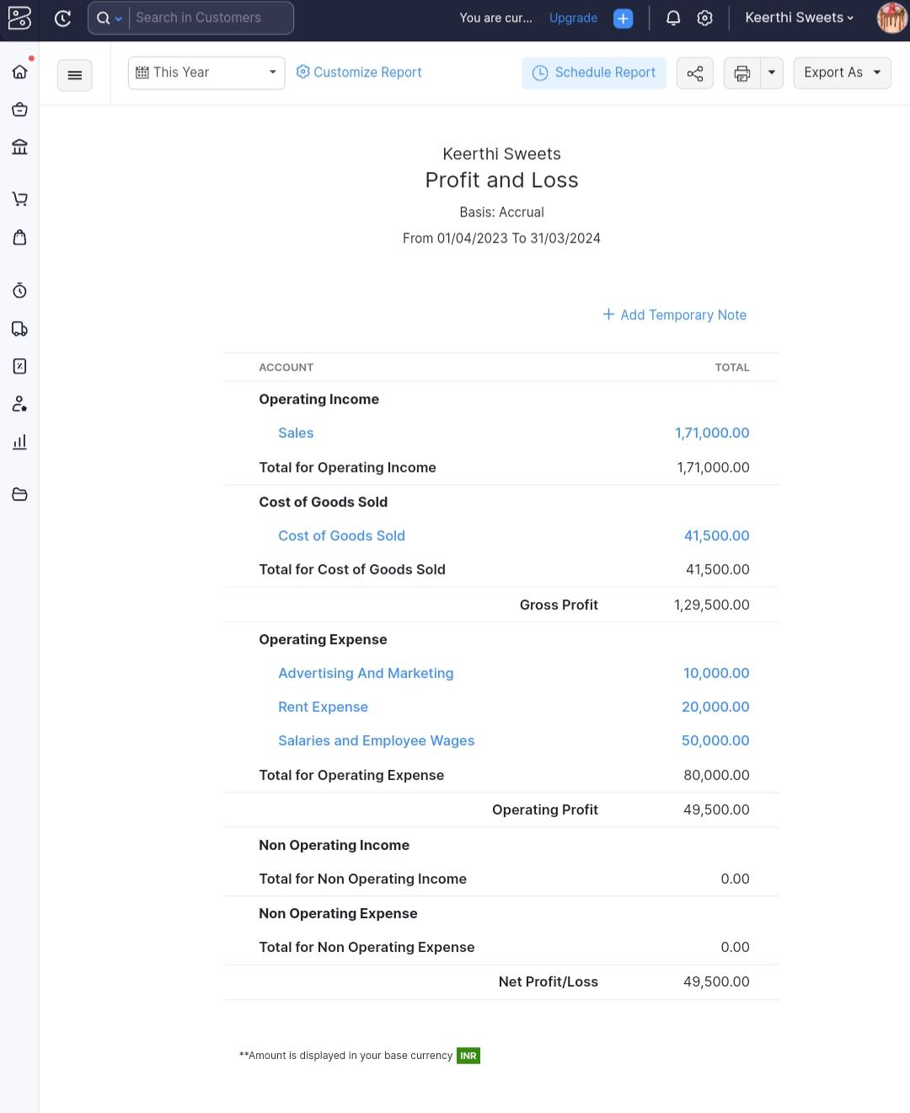6.1. Profit and loss report

6.2 Balance sheet

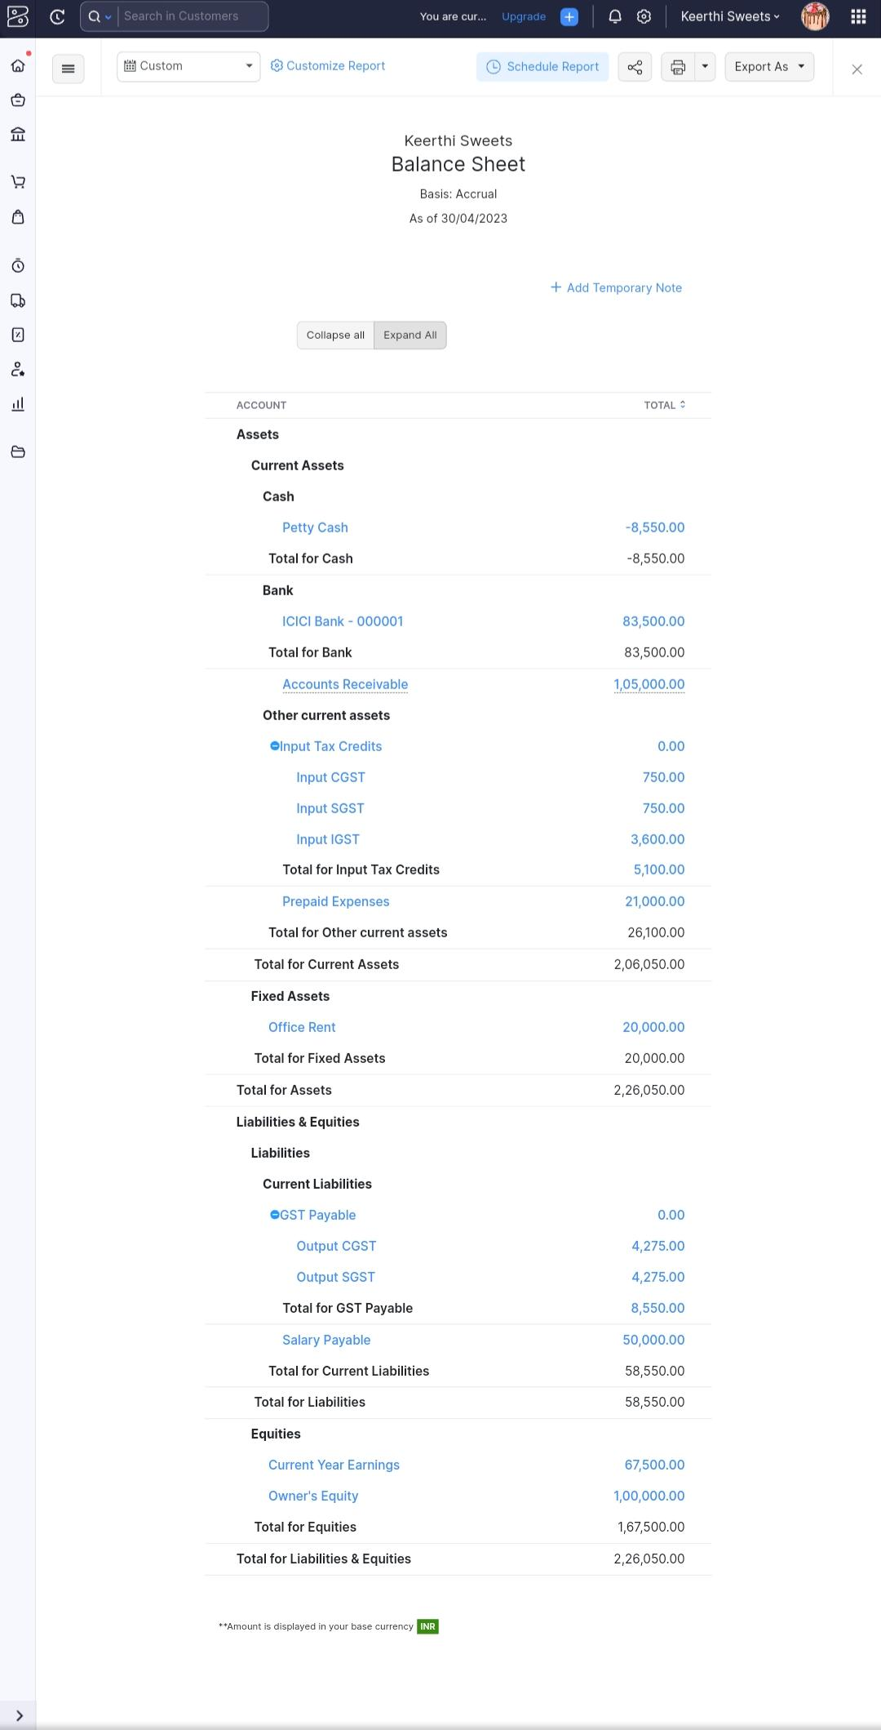

7 FUTURE SCOPE

     India is a country of festivals and traditions. There are diverse rituals performed in these festivals and having sweets is a must as offering to the god. Sweets have a relevant significance in Indians’ lives and no festival or celebration is complete without them. The mithai, a sweet that comes in many varieties are considered sattvic as it is made of sugar, milk which is pure and can be eaten by all.  Almost all the states in India have their special sweet and thanks to the migration of people from one state to another, the recipes are exchanged all over India and now almost all the varieties are available at a standard sweet shop and people with their creativity with design and flavors have made new exciting mouth-watering exotic flavored sweets and are the real deal and people are happy to pay for such delicacies. The sweet shop holds strong relevance in every Indian’s life. We have a lot of childhood memories associated with it and even when we visit a sweet shop, we get excited to try the new flavors.

The sweet industry is growing steadily every year with a growth rate in double figures and with the crowd that is around a sweet shop on every festival, it is very evident that the Sweetshop is a very profitable business.

Let’s have a look at how you can start a Sweetshop Business in India and make it profitable:

### **Create a Plan**

Decide beforehand what kind of Sweetshop you want to open. Is it just a retail shop or you’ll have in-house sweet makers and will send your own produce. With that decide what will be your reach. If you want an offline store or an online store? If it is an offline store, does it have a sitting area, or is only available for pick-ups or you will also hand out deliveries. And if it is an online store, what storage area you are going to keep your goods in, and what will be your area of service.

Make a plan for what is going to be the size of your business at first. The growth will only follow if you thrive in the market and the sweet shop business needs investment and time as the goods which are sold are perishable and cannot be stored. One should always be ready for bad days and thus also take care of the amount that is produced on a daily basis.